## Flip, Alignment and Spacing Toolbars

### Flip Toolbar

The flip toolbar allows you to flip selected objects, signs, roads, etc., either vertically or horizontally. You can also rotate these objects after selecting them by hitting **CTRL + R** on your keyboard.

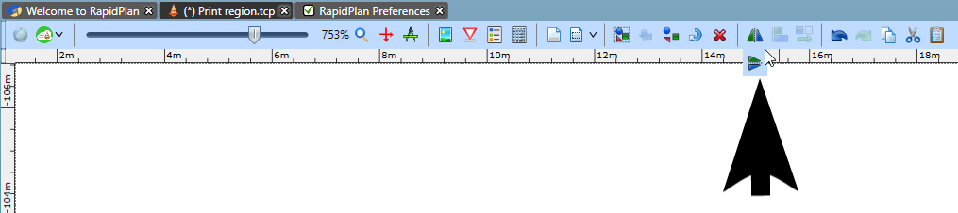

The_Flip_Toolbar

### Alignment Toolbar

This toolbar allows you to align boundaries of selected objects, signs, roads, etc. This toolbar only becomes visible when more than one object is selected.

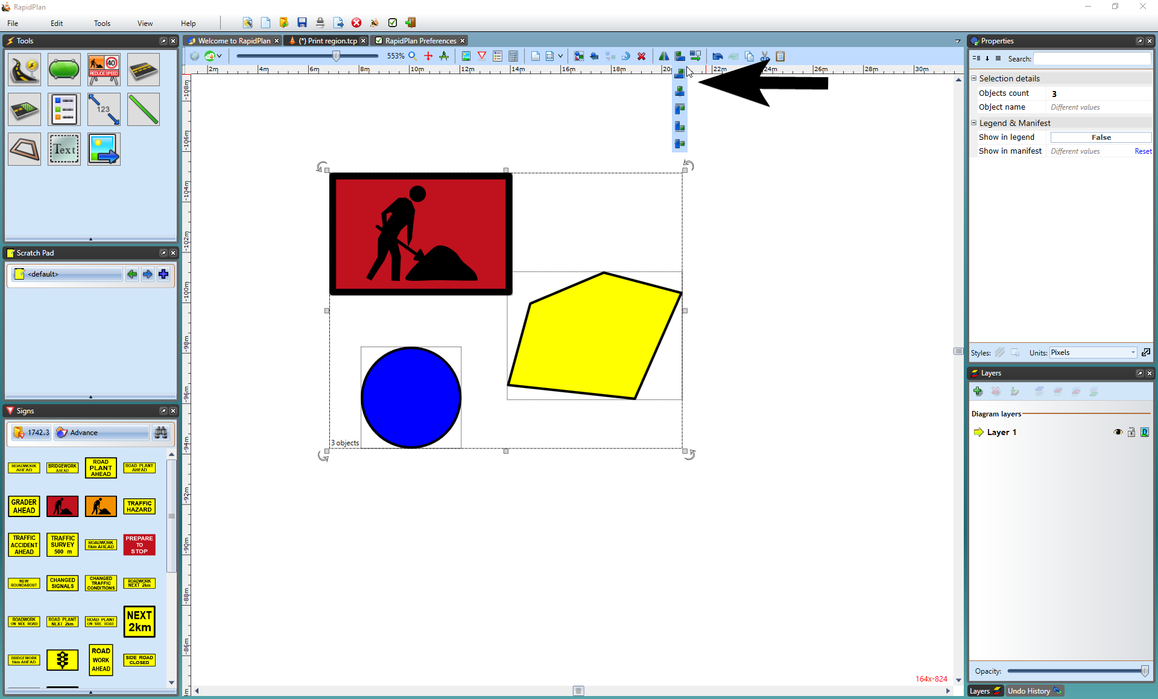

The_Alignment_Toolbar

### Spacing Toolbar

The spacing toolbar allows you to distribute any selected objects horizontally or vertically. This toolbar only becomes visible when multiple objects (three and more) are selected and encapsulated.

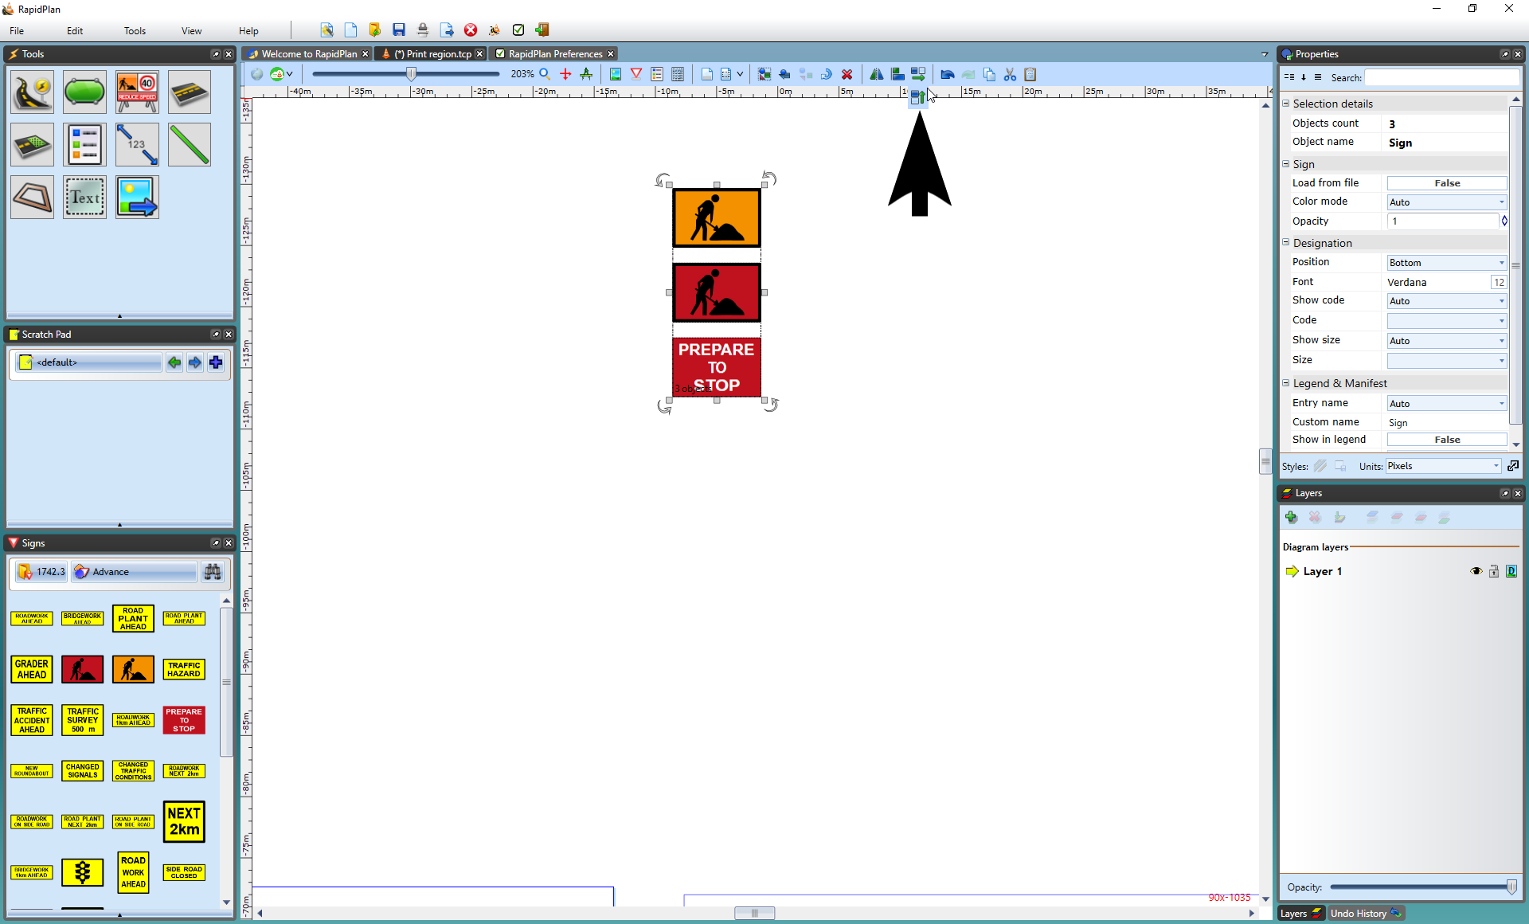

Spacing_Toolbar